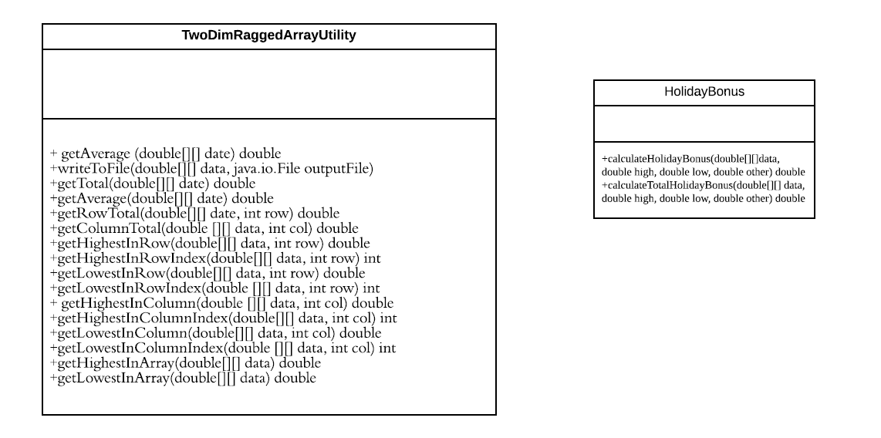

What I have learned from this is being confident. Everyone could make mistakes. Sometimes we need to be more confident about that some mistakes may be not our mistakes. After I finished my code, I found the code could not compile. I tried hard to fix it, but whatever I did, I still could not compile the code. All red lines were under the code that professor gave us. Then I thought maybe that was not my mistakes, so I tried to fix some problems with the code from the blackboard. It was lucky that code works after I fixed some problems. That is what I learned from this project. Trust yourself.